1. I don’t agree with people saying that CLI is the only way to learn Git in detail.
2. But also Git GUI tools give you much more details about what is happening in working dir and git repo.
3. **Github Desktop**:
   1. This is a GUI tool for Git.
   2. We will use it in parallel with CLI.
   3. I will show you how it reflects changes in Git Repo.
   4. Primary purpose of Github desktop is to interact with remote repo but we can use it just with local repo.
4. **Git Hub**:
   1. **Hosting Service** for Git Repo.
5. Let’s install Github Desktop.
6. 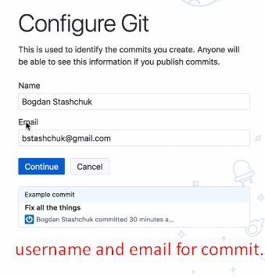
7. 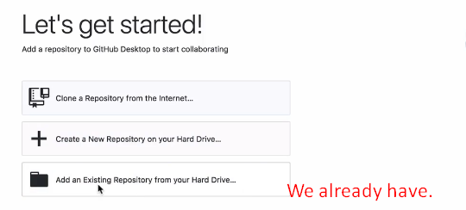
8. 